**Name: Strickland, Timothy CMSC 335 Date: 1/20/2022**

**Project 2**

**Test Table**

|  |  |  |  |
| --- | --- | --- | --- |
| **Input** | **Expected Output** | **Actual Output** | **Pass?** |
| **1** | **Prompt asking for radius** | **What is the radius of the circle?** | **Yes** |
| **5** | **Area calculation of a circle is displayed** | **Area = 78.539 with 2 dimensions** | **Yes** |
| **Y** | **Menu displayed** | **Menu** | **Yes** |
| **2** | **Prompt asking for length** | **What is the length of the rectangle?** | **Yes** |
| **5** | **Prompt asking for width** | **What is the width of the rectangle?** | **Yes** |
| **5** | **Area calculation of a rectangle is displayed** | **Area = 25.0 with 2 dimensions** | **Yes** |
| **Y** | **Menu displayed** | **Menu** | **Yes** |
| **3** | **Prompt asking for side** | **What is the side of the square?** | **Yes** |
| **5** | **Area calculation of a square is displayed** | **Area = 25.0 with 2 dimensions** | **Yes** |
| **Y** | **Menu displayed** | **Menu** | **Yes** |
| **4** | **Prompt asking for height** | **What is the height of the triangle?** | **Yes** |
| **5** | **Prompt asking for base** | **What is the base of the triangle?** | **Yes** |
| **5** | **Area calculation of a triangle is displayed** | **Area = 12.5 with 2 dimensions** | **Yes** |
| **Y** | **Menu displayed** | **Menu** | **Yes** |
| **5** | **Prompt asking for radius** | **What is the radius of the sphere?** | **Yes** |
| **5** | **Volume calculation of sphere is displayed** | **Volume = 392.699 with 3 dimensions** | **Yes** |
| **Y** | **Menu displayed** | **Menu** | **Yes** |
| **6** | **Prompt asking for edge** | **What is the edge of the cube?** | **Yes** |
| **5** | **Volume calculation of cube is displayed** | **Volume = 125.0 with 3 dimensions** | **Yes** |
| **Y** | **Menu displayed** | **Menu** | **Yes** |
| **7** | **Prompt asking for radius** | **What is the radius of the cone?** | **Yes** |
| **5** | **Prompt asking for height** | **What is the height of the cone?** | **Yes** |
| **5** | **Volume calculation of cone is displayed** | **Volume = 130.899 with 3 dimensions** | **Yes** |
| **Y** | **Menu displayed** | **Menu** | **Yes** |
| **8** | **Prompt asking for radius** | **What is the radius of the cylinder** | **Yes** |
| **5** | **Prompt asking for height** | **What is the height of the cylinder?** | **Yes** |
| **5** | **Volume calculation of cylinder is displayed** | **Volume = 392.699** | **Yes** |
| **Y** | **Menu displayed** | **Menu** | **Yes** |
| **9** | **Prompt asking for majorRadius** | **What is the majorRadius of the torus?** | **Yes** |
| **5** | **Prompt asking for minorRadius** | **What is the minorRadius of the torus?** | **Yes** |
| **5** | **Volume calculation of torus is displayed** | **Volume = 2467.401 with 3 dimensions** | **Yes** |
| **Y** | **Menu displayed** | **Menu** | **Yes** |
| **A** | **Error message** | **Bad input**  **Would you like to continue?** | **Yes** |
| **Y** | **Menu displayed** | **Menu** | **Yes** |
| **1** | **Prompt asking for radius** | **What is the radius of the circle?** | **Yes** |
| **X** | **Error message** | **Invalid input for Circle**  **Would you like to Continue?** | **Yes** |
| **N** | **Program finishes, list is printed** | **Program stops. List of shapes is printed to the console** | **Yes** |

**Screen shot 1**

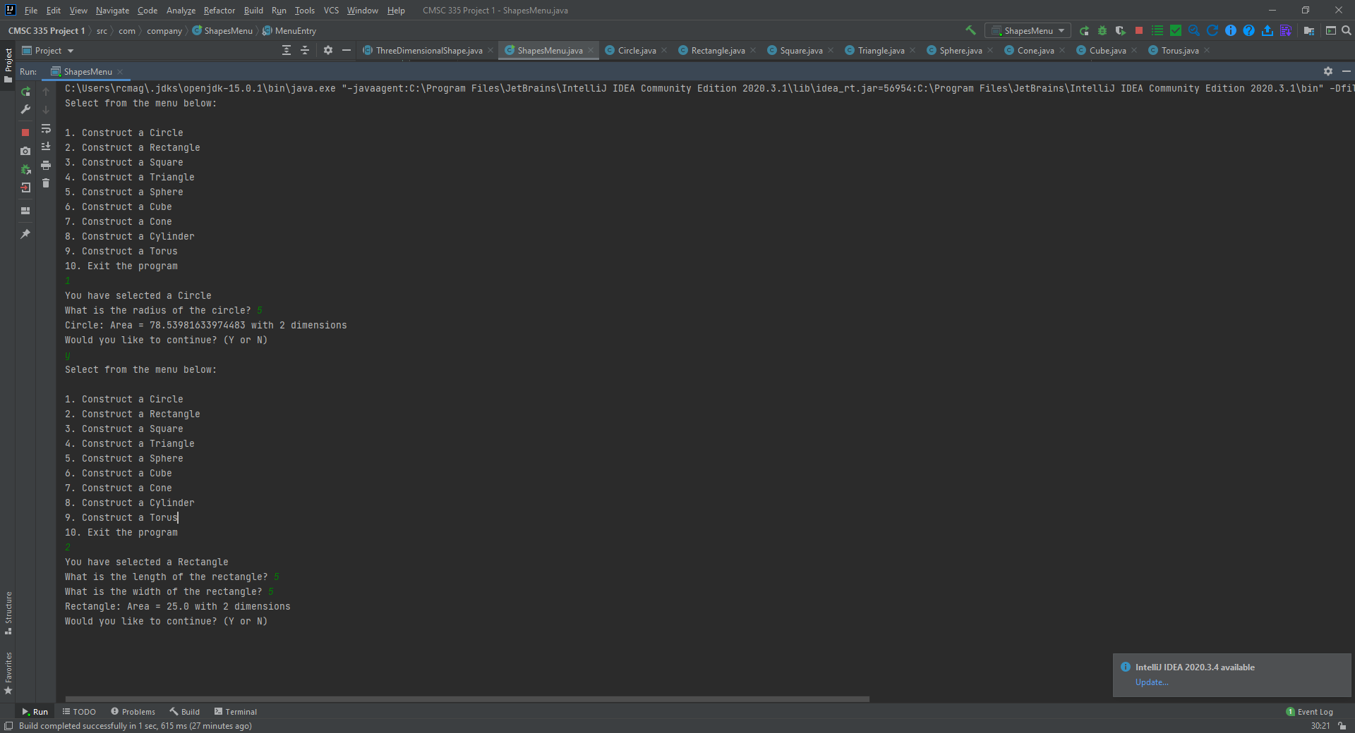

**Screen Shot 2**

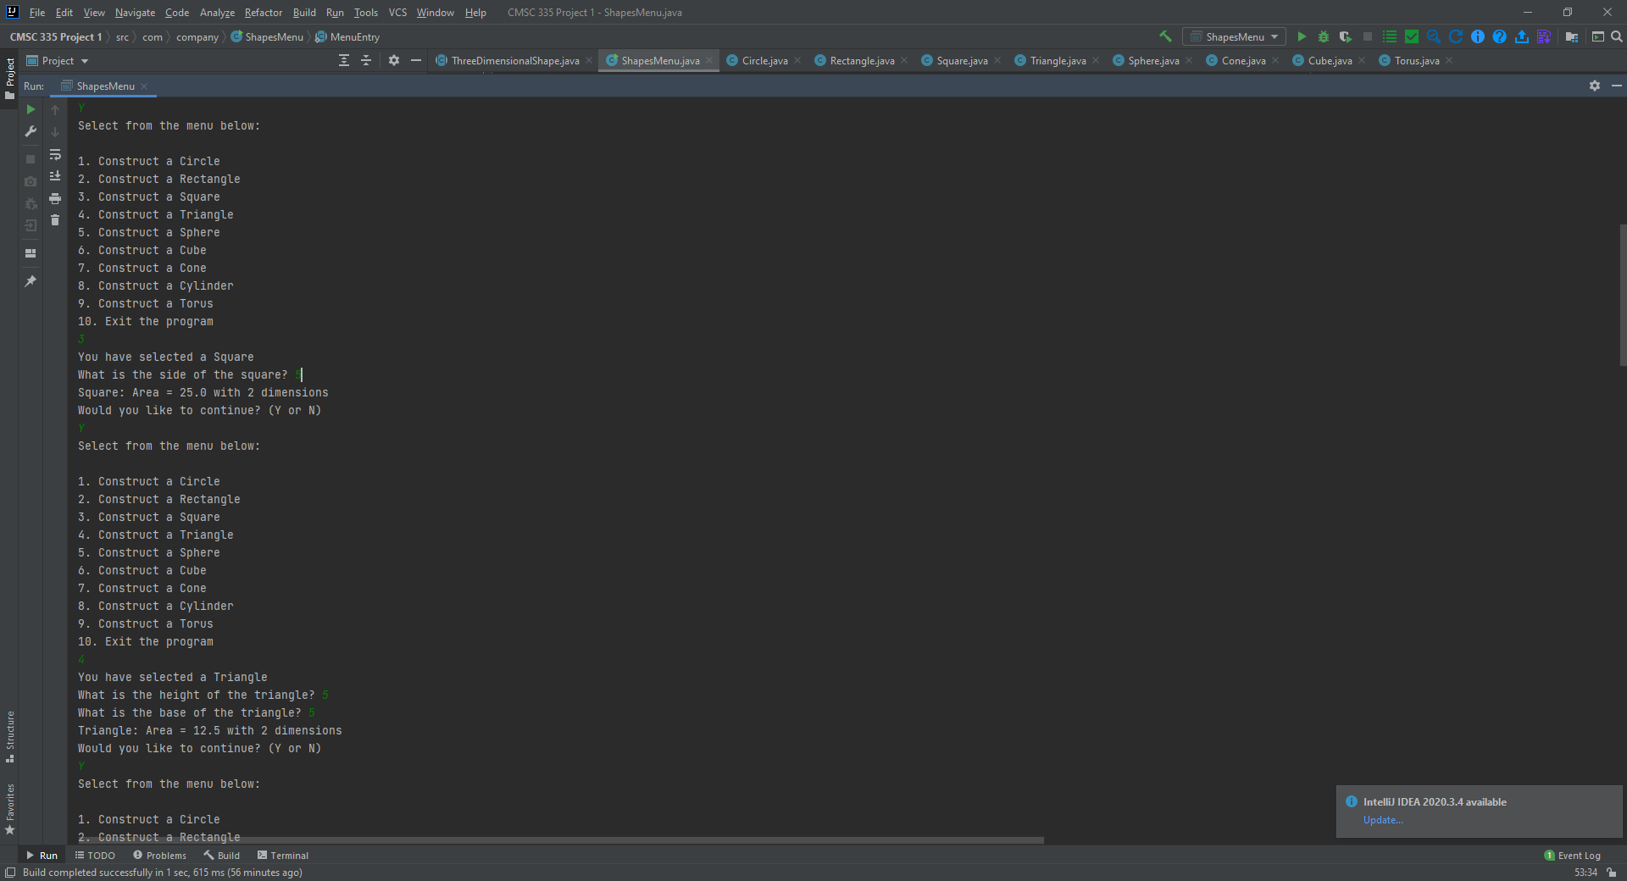

**Screen Shot 3**

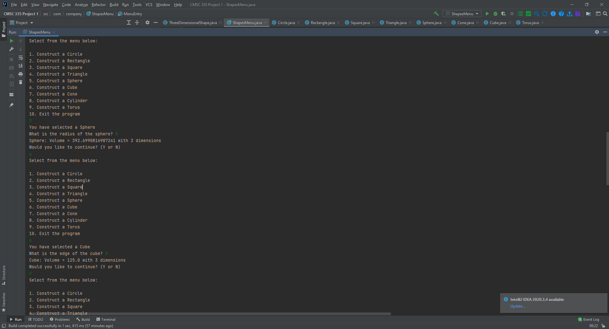

**Screen Shot 4**

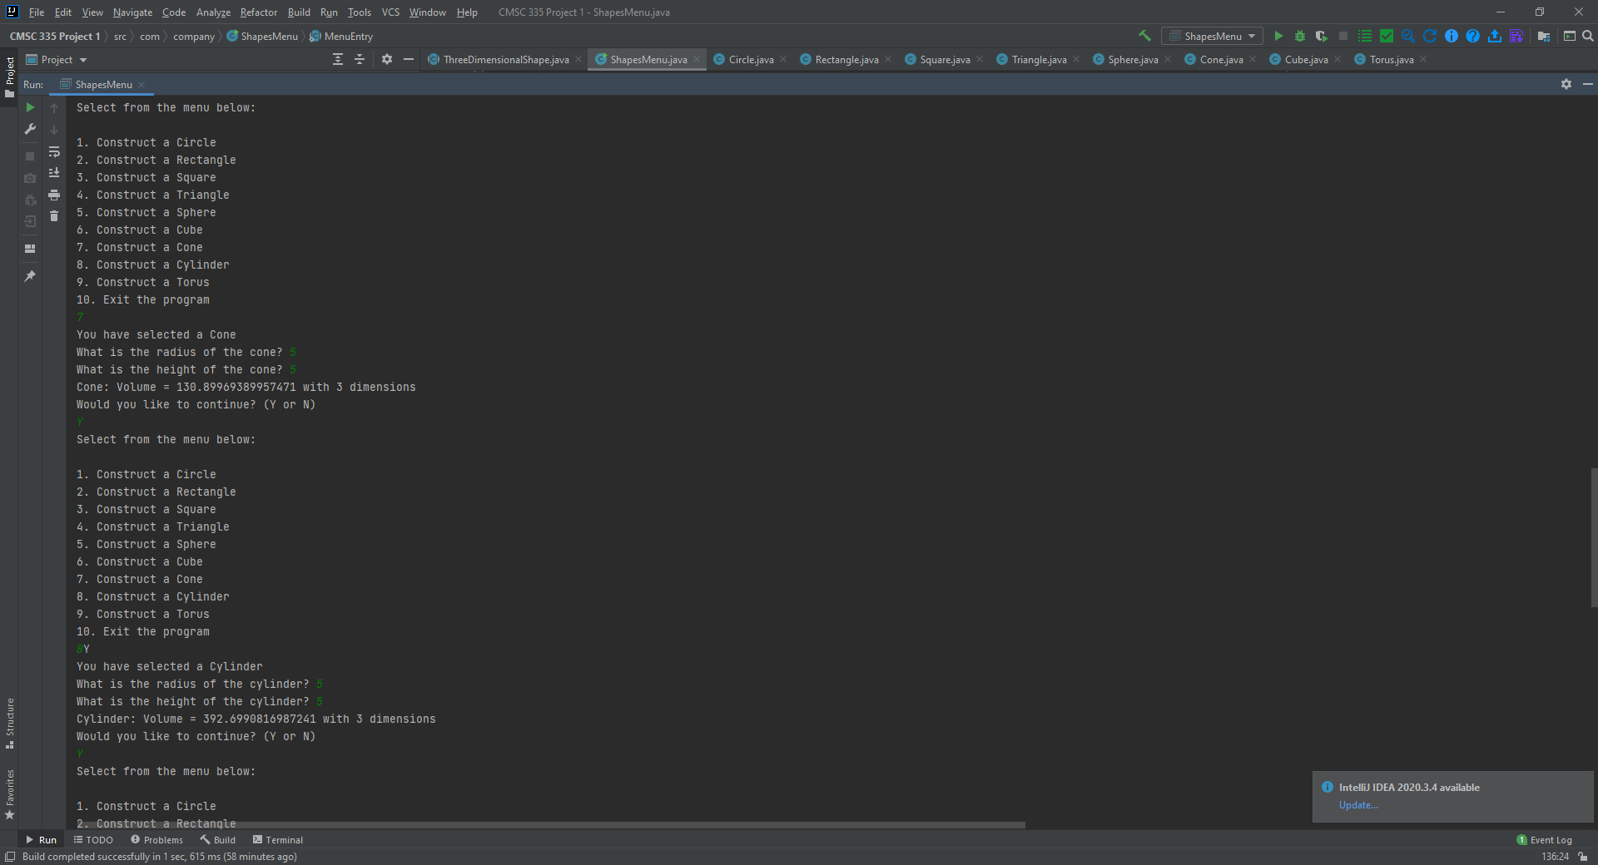

**Screen Shot 5**

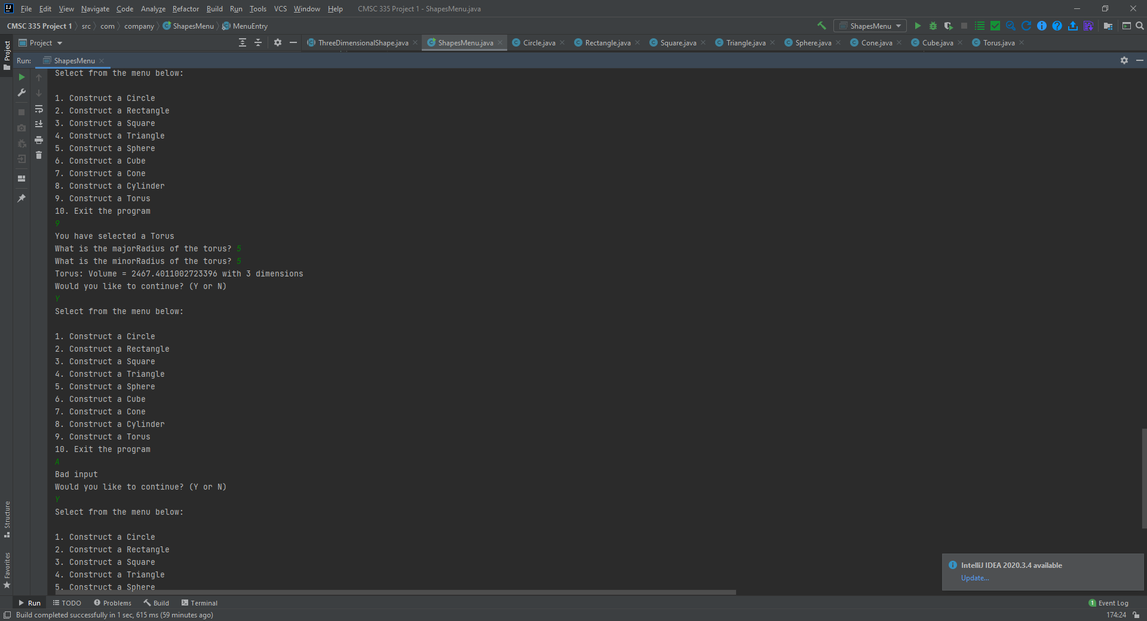

**Screen Shot 6**

